**Kids Learning Game**

**END TERM REPORT**

***By***

**Shek Istiak Sarwar Akash**

Section: K19PT

RollNumbers: A143



**Department of Intelligent Systems,**

**School of Computer Science Engineering,**

**Lovely Professional University, Jalandhar**

November-2020

**Student Declaration**

This is to declare that this report has been written by me. No part of the report is copied from other sources. All information included from other sources has been duly acknowledged. I aver that if any part of the report is found to be copied, i shall take full responsibility for it.

Signature: Akash

Name:Shek Istiak Sarwar Akash

Roll Number:A143

Place: Bangladesh

Date: 31-10-2020

**TABLE OF CONTENTS**

Kids Learning Game **PAGENO.**

|  |  |
| --- | --- |
| **1. Background and objectives of the project assigned** ........... | 1 |
| 1.1 **Motivation**..................................................................... | 1 |
| **2. Description of Project** ... ........................................................ | 2 |
| 2.1 **Code description**.............................................................. | 3 |
| **3.Framework**…………………………………………………...  **4. Work Division in terms**……………………………………..  **5. Progress synopsis**…………………………………………....  **6. SWOT Analysis achieved in the project**…………………...  **7. BONAFIDE CERTIFICATE**………………………………  **8.GitHub Link**………………………………………………... | 7  8  8  9  11  12 |

1. **Background and objectives of the project assigned:-**

Kidsare the future. We should be very careful about them and their future. Basically, for kids, sometimes it is difficult to understand the concept of reading materials easily. So, we should develop such a program which can understand the basic requirement of any kids. Also, the visual representation should be more attractive.

I try to make a very easy GUI and working functionality, which will easily understandable by kids. Of course, there is an age limitation for this application.

**1.1.Motivation:-** I get this idea and the motivation from a survey in

i saw that at the initial age of any kids it is quite a bit difficult to

understand the basic concept for learning purpose. Even a survey

shows that if the visual representation is good enough to understand

the concept only then it easy to understand and can keep the concept

Much more time in mind.

From that point of view,I think if i could manage to develop a project

Which will provide good content alone with much more good visual

The representation will easily beneficial for kids for their learning

Journey.

That’s why I try to optimize the application as much as possible.

**DESCRIPTION:**

This is a kids learnning game in which one interface will appear with six images and this interface will disappear after 10 seconds when a new interface with twelve options will appear. In this six options are correct according to the images and six are wrong. You have to select any six options. You can't select more than six options as the checkboxes will not be checked for more than six options. Then as soon as you submit, you will get your score out of six which will tell how many images you identified correctly.

**TECHNOLOGIES AND FRAMEWORK:**

I have used the Tkinter library of python to make my Graphical User Interface to make the complete project.

I have used canvas to make the background of light blue colour and adjust its height and width as 700X1200.

I have used the PhotoImage function for providing the GIF. Also, I have used create_image function to adjust the height and width of each image.

I have also a check bar with several options to select from containing correct as well as wrong answers and submit and quit button along with it as a widget and finally, I have checked the answers selected with the list of correct answers and displayed the score.

This is a kind of brain game in which kids need to memorize the image and give the correct answer.

In the game, I have added 6 picture throw which we need to give the correct answer via a check box.

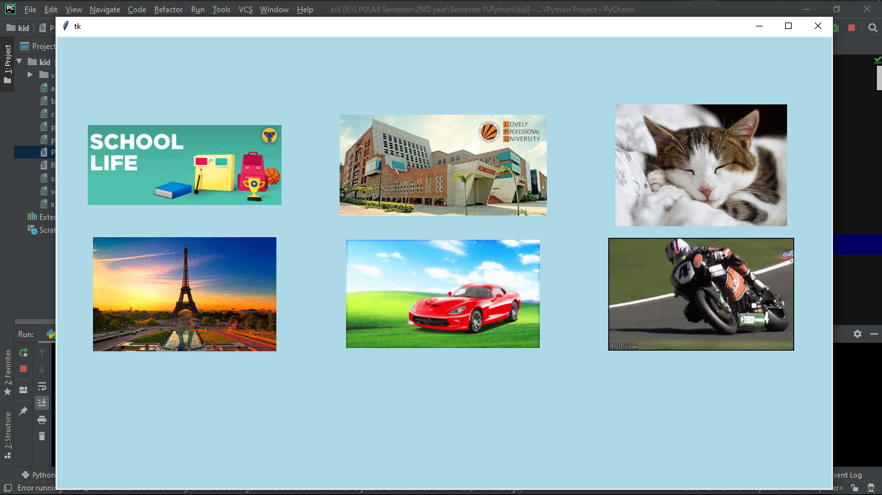

This is the 1st stage of the game which is created by

**root1=Tk()**

**c=Canvas(root1,bg='lightblue', height=700,width=1200)**

the following line of code **.**

After that inside the canvas there are 6 photo which is added by

**c.create_image(200, 200, anchor=CENTER, image=file4)**

**c.create_image(600, 200, anchor=CENTER, image=file1)**

**c.create_image(1000, 200, anchor=CENTER, image=file2)**

**c.create_image(200, 400, anchor=CENTER, image=file3)**

**c.create_image(600, 400, anchor=CENTER, image=file5)**

**c.create_image(1000, 400, anchor=CENTER, image=file6)**

this line of code. Though the images are sored in the file so I need to make a separate variable and access those photo by he module called **PhotoImage(file=” image path”)**

**file1=PhotoImage(file="abc.gif")**

**file2=PhotoImage(file="xyz.gif")**

**file3=PhotoImage(file="pqr.gif")**

**file4=PhotoImage(file="school.gif")**

**file5=PhotoImage(file="car.gif")**

**file6=PhotoImage(file="bike.gif")**

Following the code are used to import the image and add in the canvas.

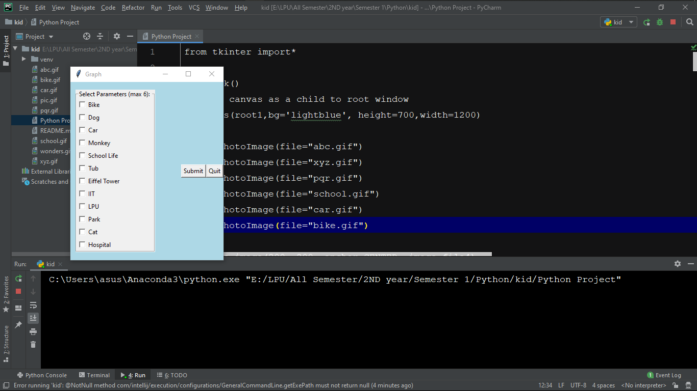

As I said earlier that after watching the 1st stage this is the 2nd stage of the game and most interesting. Hear a kid needs to memorize whatsoever was seen by 1st stage according to that we need to check out the options in which they can select maximum 6 choices, as there was 6 picture.

Actually, according to the assumption, they need to give their choice.

Also, I created a button for asking the result and button of quit if they want.

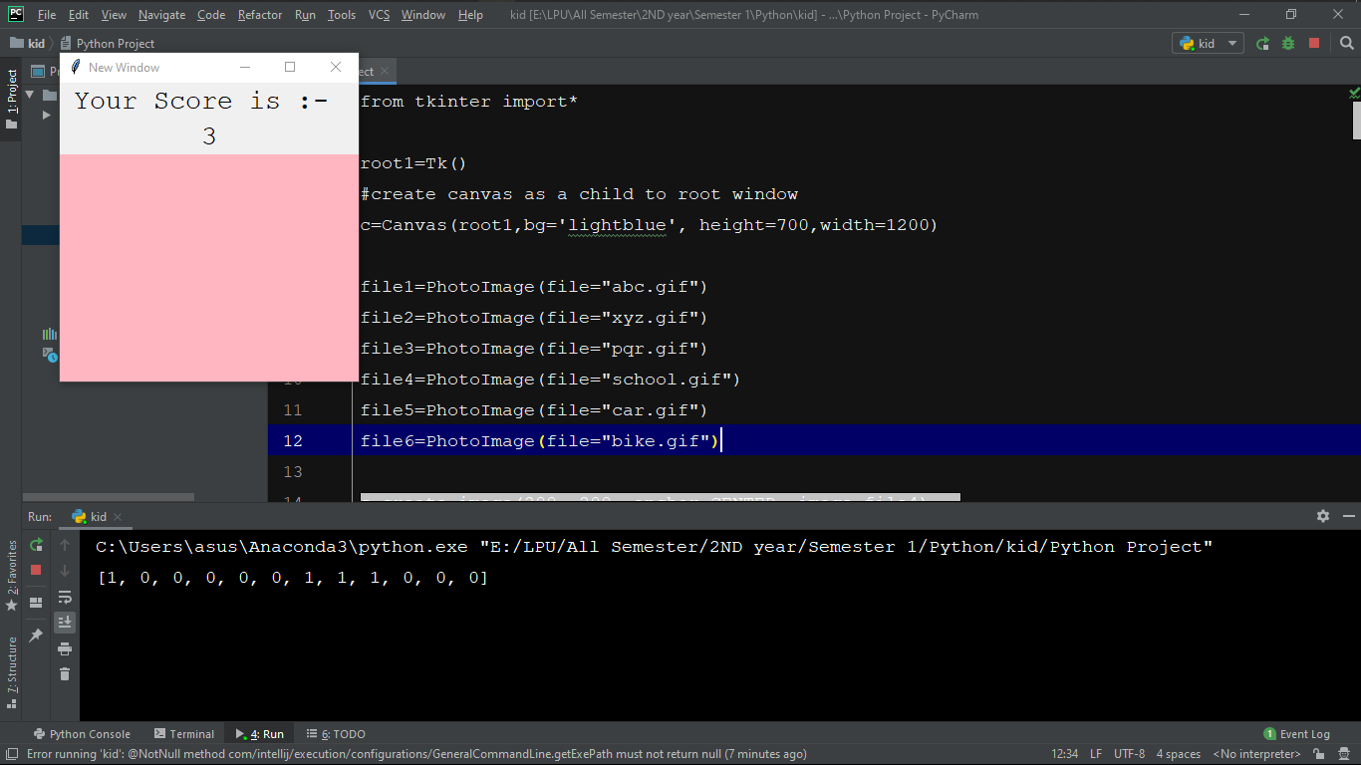Anyway, let's go to the 3rd stage and the final stage of the game.

The 3rd stage shows us the result that how much I score in the game.

I used an array of 12 in which the options are available and after submitting an array of 12 will appear with the result. As I selected 5 options among them 3 is correct and those selected options are visible via array in CMD prompt.

**FRAMEWORK:-** Hear I use python GUI framework. The library used in this project is **TKINTER.**

Tkinter tutorial provides basic and advanced concepts of Python Tkinter. Our Tkinter tutorial is designed for beginners and professionals.

Python provides the standard library Tkinter for creating the graphical user interface for desktop-based applications.

Developing desktop-based applications with python Tkinter is not a complex task. An empty Tkinter top-level window can be created by using the following steps.

* import the Tkinter module.
* Create the main application window.
* Add the widgets like labels, buttons, frames, etc. to the window.
* Call the main event loop so that the actions can take place on the user's computer screen.

I used

**from Tkinter import\***

**root1=Tk()**

to initialize a canvas and using TK() module I get all the access of the tikenter library.

**Description of Work Division in terms of Roles among Students:**

I am not work with any team. I just complete all of the project alone. Actually I am in Bangladesh . and due to corona and lockdown we all have to maintain social distance that’s why I have to stay home maximum time of the day .so I thought that if I could complete it alone then I can gather some valuable knowledge about python and uses of python . that’s why I took this project alone.

**Progress synopsis :**

After getting this project alone. First some days I just thougt that what can do. How can I do .i mean how can I implement that ,what I am thinking. Then after 10/15 days of getting this project , first time I sit for code.Then after 12 days I completed the basic structure of kids learning game.Then 2/3 days I just thought about some pictures that I can use in my kids learning game. Actually I am searcing for some pic that is confusing for kids.

After selecting pictures I insert them in my code.

Then arroung 4/5 days I worked on it and complete 95% of code.

Atleast working 2 days I totally complete my program.

Then 6/7 days I just keep cheaking that my code is properly working or not.Then before 3 days I started making project report. And it took 2 days to complete. And today I upload my code and project report in GITHUB.

**SWOT Analysis achieved in project:**

**SWOT** analysis is a strategic planning technique used to help a person or organization identify strengths, weaknesses, opportunities, and threats related to business competition or project planning.

**STRENGTHS :** at firstI try to make my game user friendly. And in my eyes my game is very easy to guess and easy to play. So the kids who will play with this game , they will not get any error or problem . and besides this I use some interesting pictures that’s why kids will not lose interest in this game.and by playing this game kids will try to remember that photos & sequence and by practicing this game they will able to memory anything easily.

**WEAKNESSES:** that is a computer computer program . so it is impossible to open it any android mobile or tablet. Bt I keep wist to make its full version and publist it in google play as my first game.

**OPPORTUNITIES :** After start making this game. I came to know about tikenter properly. By using google i came over. From all the problem. I also learn about GUI and the various uses of this. And also feel something in my heart when my first game is runned in laptop. Not i feel that i have to study more about it and have to learn all the advanced uses of python.

Actually for this opportunity i come to know about my Capacity.

**THREATS:** from the beganing to end I face so many problem. And that time I took help from google. And have discuss with my friends.

**BONAFIDE CERTIFICATE**

Certified that this project report “***KIDS LEARNING GAME*** ” is the bonafide work of “***SHEK ISTIAK SARWAR AKASH***” ***Sec: K19PT Roll: A143 Reg: 11807712*** who carried out the project work under my supervision.

### SIG:

Dr DHANPRATAP SINGH

**GitHub Link**

https://github.com/shek-istiak-sarwar-akash/learning_game_for_kids